LAB REPORT # 07



CSE-402L Digital Signal Processing Lab

Submitted by: Naveed ahmad
Registration No.: 22PWCSE2165
Class Section: B

“On my honor, as a student at the University of Engineering and Technology, I have neither given nor received unauthorized assistance on this academic work.”

Submitted to:

Dr. Yasir Saleem Afridi

January 7, 2025

Department of Computer Systems Engineering
University of Engineering and Technology, Peshawar

COMPARING DOUBLE-SIDEBAND AND SINGLE-SIDEBAND AMPLITUDE-MODULATED SIGNALS USING MATLAB

Amplitude Modulation (AM) is a technique where the amplitude of a carrier wave is varied in proportion to the message signal. In AM, two sidebands are generated: an upper sideband (USB) and a lower sideband (LSB).
- Double-Sideband AM (DSB-AM): Both sidebands are transmitted.
- Single-Sideband AM (SSB-AM): Only one of the sidebands (upper or lower) is transmitted, reducing bandwidth usage.
TASKS
- Set the sampling frequency to 100 Hz and the carrier frequency to 10 Hz. Generate a time vector having a duration of 100 s.
- Create a single-tone sinusoidal signal 1 Hz Signal.
x = sin(2*pi*t);
- Carrier Signal
yc = sin(2*pi*fc*t);
- Plot the modulating Signal and Carrier Signal
fs = 100;
fc = 10;
t = (0:1/fs:100)';
x = sin(2 * pi * 1 * t); % Modulating signal
yc = sin(2 * pi * fc * t); % Carrier signal
figure;
plot(t, x, 'r', t, yc, 'b--');
xlabel('Time (s)');
ylabel('Amplitude');
legend('Original Signal', 'Carrier Signal');
title('Figure 1: Modulating and Carrier Signal');
xlim([0.2, 2]);
ylim([-1, 1]);
xticks(0.2:0.2:2);
yticks(-1:0.2:1);
grid on;

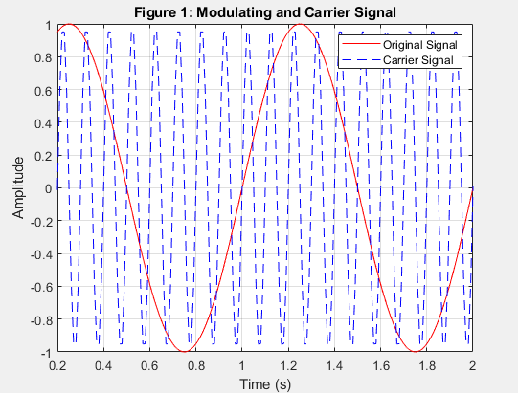

The figure shows a modulating signal with a frequency of 1 Hz and a carrier signal of 10 Hz.
- Modulate x using single- and double-sideband AM.
%Modulate signals
t = (0:1/fs:10)';
x = sin(2 * pi * 1 * t); % Modulating signal
carrier_cos = cos(2 * pi * fc * t); % Cosine carrier
carrier_sin = sin(2 * pi * fc * t); % Sine carrier
% Double-Sideband Modulation (DSB)
ydouble = x .* carrier_cos;
% Hilbert Transform for SSB (Single Sideband Modulation)
x_hilbert = imag(hilbert(x));
% Lower Sideband (LSB)
lowerSidebandSignal = x .* carrier_cos - x_hilbert .* carrier_sin;
% Upper Sideband (USB)
upperSidebandSignal = x .* carrier_cos + x_hilbert .* carrier_sin;

figure;
subplot(3,1,1);
plot(t, ydouble);
title('Double-Sideband AM');
xlabel('Time (s)');
ylabel('Amplitude');

subplot(3,1,2);
plot(t, lowerSidebandSignal);
title('Lower Sideband Signal (LSB)');
xlabel('Time (s)');
ylabel('Amplitude');

subplot(3,1,3);
plot(t, upperSidebandSignal);
title('Upper Sideband Signal (USB)');
xlabel('Time (s)');
ylabel('Amplitude');

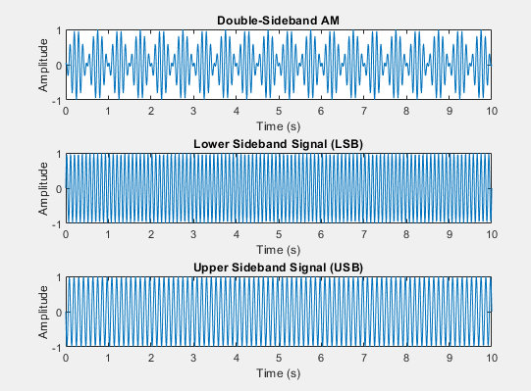
- DSB modulation multiplies the baseband signal with the carrier signal.
- SSB modulation eliminates one of the sidebands (upper or lower) using the Hilbert transform.

- Plot the DSB, USB, and LSB signals.

% Spectrum Analysis Using FFT
n = length(t); % Number of samples
f = (-n/2:n/2-1) * (fs/n); % Frequency vector
% Compute FFT for each signal
fft_double = fftshift(abs(fft(ydouble))/n);
fft_lsb = fftshift(abs(fft(lowerSidebandSignal))/n);
fft_usb = fftshift(abs(fft(upperSidebandSignal))/n);

% Plot Spectrum
figure;
subplot(3,1,1);
plot(f, fft_double);
title('Spectrum of Double-Sideband Signal');
xlabel('Frequency (Hz)');
ylabel('Amplitude');

subplot(3,1,2);
plot(f, fft_lsb);
title('Spectrum of Upper Sideband Signal');
xlabel('Frequency (Hz)');
ylabel('Amplitude');

subplot(3,1,3);
plot(f, fft_usb);
title('Spectrum of Lower Sideband Signal');
xlabel('Frequency (Hz)');
ylabel('Amplitude');

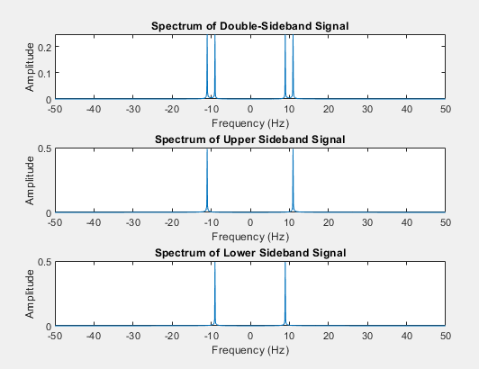
We’ve performed FFT on DSB, USB, and LSB signals and observed the spectrum of the signals.
Demodulate the lower and upper sideband signals

% Define a proper low-pass filter
lpFilt = designfilt('lowpassfir', 'PassbandFrequency', 2, ...
'StopbandFrequency', 5, 'PassbandRipple', 0.5, 'StopbandAttenuation', 60, ...
'SampleRate', fs);

% Demodulate Lower Sideband Signal (LSB)
demod_lsb = lowerSidebandSignal .* cos(2 * pi * fc * t); % Multiply with carrier
s1 = filtfilt(lpFilt, demod_lsb); % Apply low-pass filter

% Scale demodulated signal to match original amplitude
s1 = s1 / max(abs(s1)) * max(abs(x));

% Demodulate Upper Sideband Signal (USB)
demod_usb = upperSidebandSignal .* cos(2 * pi * fc * t); % Multiply with carrier
s2 = filtfilt(lpFilt, demod_usb); % Apply low-pass filter

% Scale demodulated signal to match original amplitude
s2 = s2 / max(abs(s2)) * max(abs(x));

The modulated signal is multiplied by the carrier and passed through a low-pass filter to get back the original message signal.
- Compare processed signals with the original and verify reconstruction.

figure;
plot(t, x, 'k', t, s1, 'r:', t, s2, 'g-.'); % Plot original and demodulated signals
title('Comparison of Original and Demodulated Signals');
xlabel('Time (s)');
ylabel('Amplitude');
legend('Original Signal', 'Demodulated LSB', 'Demodulated USB');
xlim([0.2, 3.5]); % Adjust time range for better visualization
grid on;

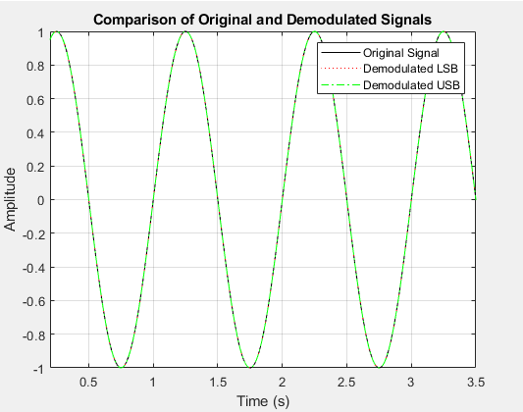
Plotting the message and demodulated signals together shows that they closely match each other.
Answer the following Questions
1.plot the power density:

%Power Spectral Density using periodogram
[pxx, f_psd] = periodogram(x, rectwin(length(x)), length(x), fs, 'power');

% Plot PSD
figure;
plot(f_psd, 10*log10(pxx)); % Convert power to dB scale
title('Power Spectral Density');
xlabel('Frequency (Hz)');
ylabel('Power/Frequency (dB/Hz)');
grid on;

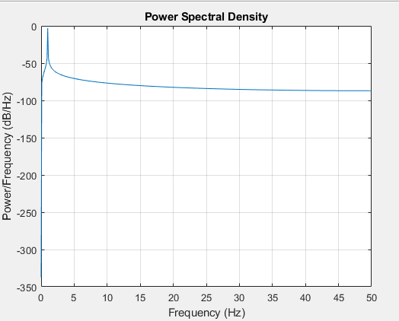
The PSB represents the distribution of power across frequencies.
Plot the Spectrum. Choose Spectrum Unit as dBW, dBm, and Watts

%Plotting the Spectrum
n = length(x);
fft_x = fft(x); % Perform FFT
f_fft = (0:n-1) * (fs/n); % Frequency axis
fft_mag = abs(fft_x) / n; % Normalize

% Plot
figure;
plot(f_fft(1:n/2), 10*log10(fft_mag(1:n/2))); % One-sided spectrum
title('Signal Spectrum');
xlabel('Frequency (Hz)');
ylabel('Magnitude (dB)');
grid on;

% Spectrum in Watts
figure;
subplot(3,1,1);
plot(f_fft(1:n/2), fft_mag(1:n/2));
title('Spectrum in Watts');
xlabel('Frequency (Hz)');
ylabel('Amplitude (Watts)');
grid on;% Spectrum in dBm
spectrum_dBm = 10 * log10(fft_mag(1:n/2).^2 * 1000);
subplot(3,1,2);
plot(f_fft(1:n/2), spectrum_dBm);
title('Spectrum in dBm');
xlabel('Frequency (Hz)');
ylabel('Power (dBm)');
grid on;

% Spectrum in dBW
spectrum_dBW = 10 * log10(fft_mag(1:n/2).^2);
subplot(3,1,3);
plot(f_fft(1:n/2), spectrum_dBW);
title('Spectrum in dBW');
xlabel('Frequency (Hz)');
ylabel('Power (dBW)');

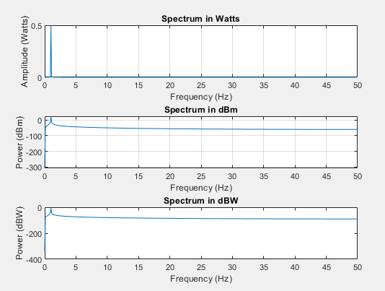

CONCLUSION:
In this lab, we explored modulation and demodulation techniques to understand the transmission and recovery of signals. Double-Sideband (DSB) and Single-Sideband (SSB) modulation methods were implemented, and their frequency spectra were analyzed. Demodulation techniques successfully reconstructed the original signal, verified by comparing it with the demodulated outputs.

